Name: Addie Clark
Assignment: HU14 ANLY 540 Portfolio Assignment 4: Interpret Analysis and Provide Recommendations KA2 90%3
Date:7-DEC-2025

Do Predictive Language Models Capture Human Semantic Priming? A Comparison of Surprisal Values Across GPT2, RoBERTa, and Bloom-560m.
Semantic priming is a decrease in response latency from the participant when a target word is preceded by either a related cue word or an unrelated cue word (Buchanan et al., 2025). This priming value is typically quantified by measuring participants response time (higher response times indicate the words are less related, while lower response times indicate the words are more related). In psycholinguistics, semantic priming is used to examine cognitive processes like word recognition and to reveal how semantic knowledge is structured and organized in the human brain. This idea often focuses on the mechanisms behind this effect which include spreading activation theory (Collins and Loftus, 1975), automatic spreading activation (where activation spreads through a network), and strategic mechanism (retrospective retrieval) (Heyman et al., 2016).
These ideas have been revamped in recent years in the computational psychology space to include Language Models (LMs) that have been trained on the task of estimating word probabilities in context (Misra et al., 2020). For this study GPT2 (Radford et al., 2019), RoBERTa (Liu et al., 2019), and Bloom-560m (Building a TB Scale Multilingual Dataset for Language Modeling, 2021) models were used. GPT2 is an incremental LM that generates text and calculates probabilities based on preceding context only (Jumelet et al., 2024). RoBERTa is a type of BERT model that utilizes a bidirectional transformer network and is trained using a Masked LM objective optimizing context from both sides to predict masked words (Misra et al., 2020). Bloom-560m is a decoder only transformer that is trained on autoregressive language-modeling (Le et al., 2022). We use these models to compute surprisal for each related and unrelated cue-target pair and derive a priming delta (surprisal unrelated – surprisal related) to emulate the human reaction time priming effects. Embedding based similarity differences are also computed as a second predictor of priming. The research question is:
Do LLM surprisal-based priming deltas and embedding similarity predict human semantic priming, and to what extent do their semantic structures resemble human data?
The dataset used in this project consisted of semantic priming stimuli constructed from cue-target word pairs. Each item included a target word, related cue, and unrelated cue that was run through four context sentences, once with the target word and related cue and a second time with the target word and the unrelated cue:
Context 1
"Given the word ", cue_word_related, ", the next word is ", target_word_unique
"Given the word ", cue_word_unrelated, ", the next word is ", target_word_unique
Context 2
"After the word ", cue_word_related, ", comes the word ", target_word_unique
"After the word ", cue_word_unrelated, ", comes the word ", target_word_unique
Context 3
"The pair begins with ", cue_word_related, ", and continues with ", target_word_unique
"The pair begins with ", cue_word_unrelated, ", and continues with ", target_word_unique
Context 4
"If the first word is ", cue_word_related, ", the next word you’ll see is ", target_word_unique
"If the first word is ", cue_word_unrelated, ", the next word you’ll see is ", target_word_unique

This allowed for a comparison of model behavior utilizing related versus unrelated contexts. Each trial contained the surprisal of the target given the related cue (surprisal_A), the surprisal of the target given the unrelated cue (surprisal_B), and the derived priming_delta. The priming delta was used to construct the reaction time seen in human data trials. Corresponding human behavioral measures were merged into this dataset to allow for a direct comparison between human and model-based priming.
To initiate the process the human dataset was prepared by aggregating the Z-scored reaction-time measures for each target word to compute three variables: the human Z-Reaction Time (Z-RT) after a related cue (Z-RT_{related)}, the Z-RT after an unrelated cue (Z-RT_{unrelated}), and a human priming delta. After constructing the human priming dataset, it was merged with the precomputed language model surprisal outputs. Because the surprisal values (surprisal_A, surprisal_B, and priming_delta) had already been computed, the next step was to aggregate LM priming by target word and model so that each item had a single priming estimate per model.
Next descriptive statistics on surprisal and priming were reviewed, both overall and separately for each model, to examine the distributional properties of the LM priming deltas and compare them to human priming. With the datasets fully aligned, computed embeddings for each model (GPT-2, Bloom-560m, and RoBERTa) were used to calculate cosine similarity between each target and its related verses unrelated cues. Plotted KDE curves were created to visualize how strongly each model differentiates related from unrelated pairs in embedding space (Appendix 1).
After obtaining similarity values, regression models were run to test whether similarity difference scores predicted LM priming deltas and visualized these relationships with scatterplots. Further regression testing regarding whether embedding similarity predicted surprisal in related and unrelated contexts individually. Once these item-level analyses were complete, LM similarity values were aggregated by target and model to be merged with the human priming data. This allowed a full correlation matrix assessing how well each model’s similarity and priming measures aligned with human priming behavior
Item-level predictions were then analyzed the global semantic structure of the models. Using RoBERTa embeddings, a large semantic network was constructed, and Louvain community detection was applied to identify major clusters of semantically related words. An extracted semantic hub subgraph (top 100 highest-degree nodes) was created to identify central connector words within the embedding geometry. Lastly, a full network-statistics summary was developed that included degree, betweenness, closeness, clustering, and connected components as a way to quantify the structural organization of the embedding-derived semantic network.
Across all models, surprisal values showed variability with surprisal_A (M = 25.81, SD =
24.20) and surprisal_B (M = 28.34, SD = 17.60) indicating a variance in contextual predictability across cue types. The resulting model priming deltas were small on average (M = 2.53, SD = 8.46). Human priming deltas were centered around zero (M = -0.00, SD = 0.32), consistent with the Z-scored normalization applied to reaction times. Embedding similarity differences were very small for all models (GPT2: M = 0.003, Bloom-560m: M = 0.006, RoBERTa: M = 0.006), with narrow ranges for GPT2 and RoBERTA with much broader variability for Bloom-560m. These values provide the baseline characteristics for regressions to follow.
Variable | N | Mean | SD
surprisal_A | 12,000 | 25.808 | 24.201
surprisal_B | 12,000 | 28.339 | 17.600
priming_delta | 12,000 | 2.532 | 8.457
human_priming_delta | 12,000 | -0.000 | 0.319
gpt2_sim_diff | 12,000 | 0.003 | 0.013
bloom_sim_diff | 12,000 | 0.006 | 0.088
roberta_sim_diff | 12,000 | 0.006 | 0.016

Table 1. Summary of descriptive statistics.
Correlations were computed between human priming deltas, LM priming deltas, and embedding based similarity differences to assess the degree of similarity between human and model behavior. Next, network metrics provided a structural view of how each model organized semantic relationships independent of specific cue-target predictions. Regressions were also performed to examine whether embedding similarity differences and surprisal based metrics significantly predicted human priming effects. These methods provide a comprehensive evaluation of how well the transformer models captured both the structure of human semantic priming.
To assess whether LMs exhibit human like semantic priming, correlations between the derived human priming deltas and the LM surprisals were performed (Figure 1). Correlations were extremely small across the models. Neither GPT2 nor Bloom-560m showed any detectable relationship between their surprisal based priming deltas and human priming (r < 0.04). Embedding similarity differences were uninformative with correlations near zero for the GPT2 and Bloom-560m models as well. RoBERTa however had embedding differences that correlated moderately with GPT2 similarity differences (r = 0.53), suggesting that the two models capture overlapping semantic structure. Additionally, RoBERTa’s similarity difference was the only predictor associated with human priming (r = 0.26). Although small, this does suggest that RoBERTa captures some aspects of human like semantic priming not captured by surprisal.
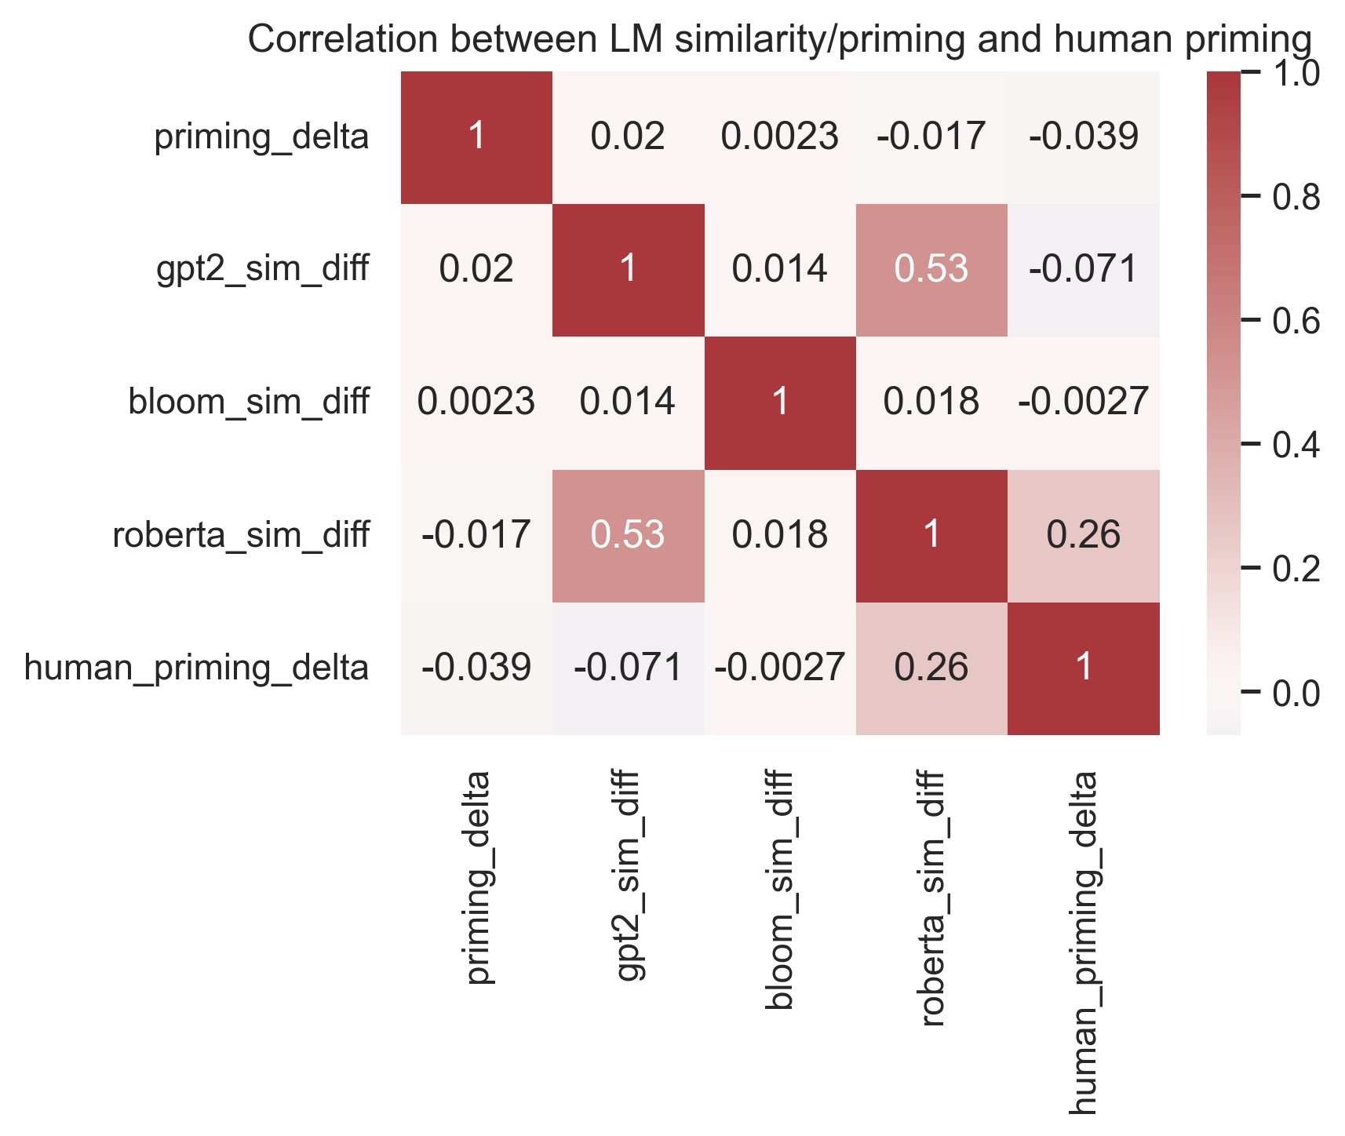
Figure 1. Correlation between LMs similarity and priming with human priming

Regression analyses tested whether embedding similarity differences predicted LLM surprisal based priming deltas and whether these model derived measures aligned with human priming. Across all models, results showed very low R² and AIC values indication poor explanatory power. GPT2 showed a statistically significant positive coefficient, but the effect size explains nearly none of the variance (R² = 0.0003), indicating that the significance is driven by samples size rather than predicative value. Bloom-560m showed no relationship between similarity and priming delta. RoBERTa showed a marginal negative effect (p = 0.094), but the model still explains none of the variance.
Model | Coefficient Estimate | p-value | R² | AIC
GPT2 | 11.97 | 0.043 | 0.0003 | 85293.45
Bloom-560m | 0.20 | 0.815 | 0.0000 | 85297.48
RoBERTa | -7.94 | 0.094 | 0.0002 | 85294.73

Table 2. Regression Analyses for Predicting LM Priming Delta
Across all models’ similarity differences failed to predict either surprisal_A or surprisal_B. Coefficients were small, non-significant, and accompanied by R2 values that are indistinguishable from zero. Indicating that embedding similarity and contextual predication are largely independent of these models.
Model | p-value | R2
GPT2
surprisal_A | 0.814 | 0.0000
surprisal_B | 0.196 | 0.0001
Bloom-560m
surprisal_A | 0.913 | 0.0000
surprisal_B | 0.969 | 0.0000
RoBERTa
surprisal_A | 0.874 | 0.0000
surprisal_B | 0.558 | 0.0000

Table 3. Regression Analyses for Predicting surprisal_A and surprisal_B.
A network was constructed to characterize broader semantic struct where the nodes represented target words and edges reflected cosine similarity derived from the sentence transformer embeddings. Louvain community detection revealed five major communities, indicating moderately differentiated semantic clusters. The average degree of the full graph was 14.19 with a maximum degree of 113, suggesting there is a presence of high-connectivity hub nodes. A visualization focused on the top 100-most connect hub words, highlighting central concepts that serve as anchors in the model’s semantic space (Appendix 2).
Across all analyses the models exhibit minimal human like priming behavior. Surprisal based priming deltas do not correlate with human priming or embedding similarity and embedding similarity itself is not predictive of surprisal. The only notable signal is RoBERTa’s embedding similarity that modestly correlates with human priming (r = 0.26), suggesting that
RoBERTa captures some aspect of semantic human like relatedness. However, this representation similarity does not translate into contextual prediction behavior resembling human priming; as seen in the weak regression outputs.
The results show that transformer-based language models only weakly reproduce human semantic priming behavior. Although they encode semantic structure in their personal embedding spaces, the similarity does not translate into human-like predicative processing. Surprisal based priming deltas were small, inconsistent, and uncorrelated with human priming effects. RoBERTA did show a modest correlation between embedding similarity and human priming but failed to exhibit the reduction in its surprisal values. This disconnection suggests that structural semantic similarity and contextual prediction rely on internal mechanisms within the models.
Some updates can be applied to improve the model behavior and human semantic priming. The initial approach would be to include a new LM that is larger or has different optimizing approaches (e.g., LLaMA); this may assist with more human like sensitivity to contextual cues to improve objectives. Methodological changes could also enhance the model to human comparability. Mixed effect models could be used to control for lexical properties such as frequency, concreteness, and neighborhood density that influence human priming. Together these updates can highlight multiple paths toward bridging the gap between distributional representation in LMs and the semantic processes observed in humans.
This project evaluated if transformer based LMs show human like semantic priming by comparing surprisal based priming deltas, embedding similarity differences, and network structure to human reaction time data. Although RoBERTa’s embeddings captured some aspects of human semantic relatedness, none of the models demonstrated priming in surprisal. The results indicate that LMs encode structured semantic spaces but do not reproduce dynamics underlying human priming. These findings suggest there is some distinction between semantic representation and predictive processing the current models and point towards future work that is needed to close this gap.

References
Buchanan, E. M., Cuccolo, K., Heyman, T., Van Berkel, N., Coles, N. A., Iyer, A., ... & Ghasemi, H. (2025). Measuring the semantic priming effect across many languages. Nature human behaviour, 1-20.
Building a TB Scale Multilingual Dataset for Language Modeling. (2021). Huggingface.co. https://bigscience.huggingface.co/blog/building-a-tb-scale-multilingual-dataset-for-languagemodeling
Collins, A. M., & Loftus, E. F. (1975). A spreading-activation theory of semantic processing. Psychological review, 82(6), 407.
Heyman, T., Hutchison, K. A., & Storms, G. (2016). Is semantic priming (ir) rational? Insights from the speeded word fragment completion task. Journal of Experimental Psychology: Learning, memory, and cognition, 42(10), 1657.
Jumelet, J., Zuidema, W., & Sinclair, A. (2024). Do language models exhibit human-like structural priming effects?. arXiv preprint arXiv:2406.04847.
Le Scao, T., Wang, T., Hesslow, D., Bekman, S., Bari, M. S., Biderman, S., ... & Beltagy, I. (2022, December). What language model to train if you have one million gpu hours?. In Findings of the Association for Computational Linguistics: EMNLP 2022 (pp. 765-782).
Liu, Y., Ott, M., Goyal, N., Du, J., Joshi, M., Chen, D., ... & Stoyanov, V. (2019). Roberta: A robustly optimized bert pretraining approach. arXiv preprint arXiv:1907.11692.
Misra, K., Ettinger, A., & Rayz, J. (2020, November). Exploring BERT’s sensitivity to lexical cues using tests from semantic priming. In Findings of the Association for Computational Linguistics: EMNLP 2020 (pp. 4625-4635).
Radford, A., Wu, J., Child, R., Luan, D., Amodei, D., & Sutskever, I. (2019). Language models are unsupervised multitask learners. OpenAI blog, 1(8), 9.

Appendix 1. Plotted KDE curves representing how strongly each model differentiates related from unrelated pairs in embedding space
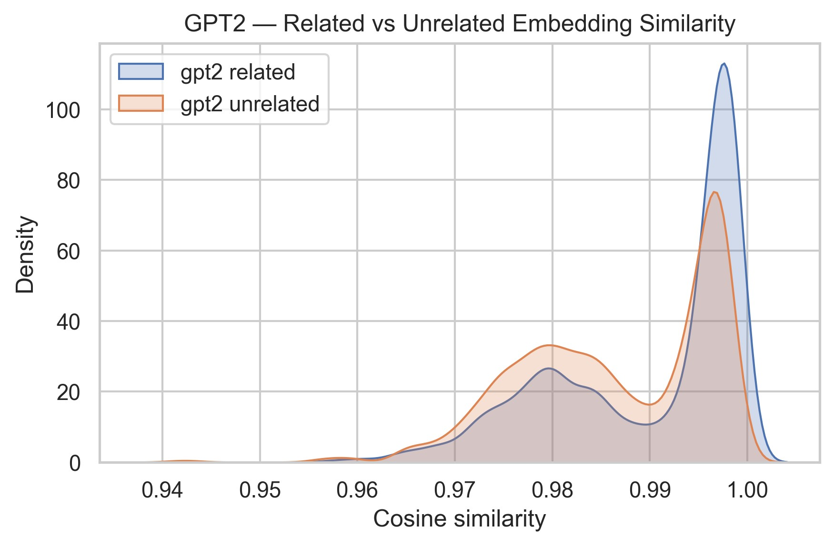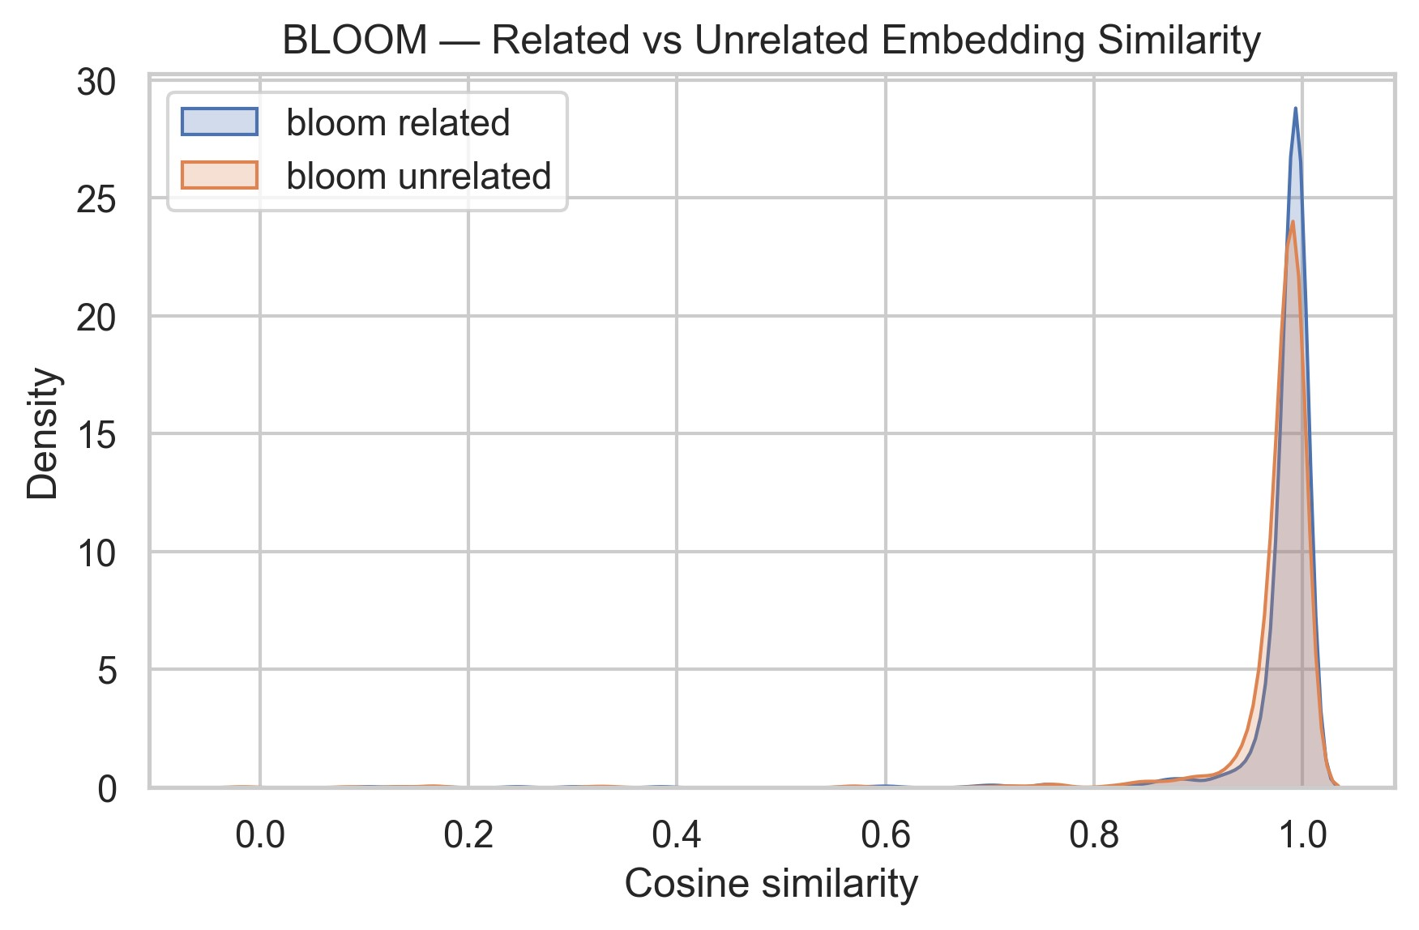
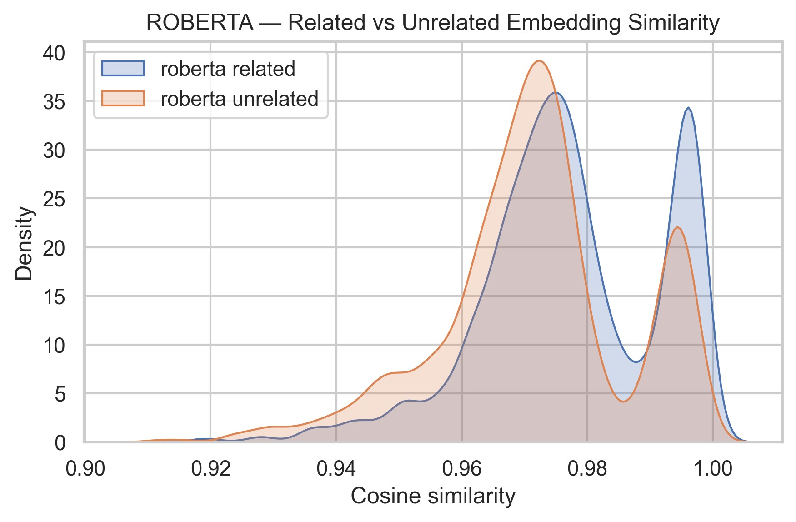

Appendix 2. The top 100-most connect hub words


